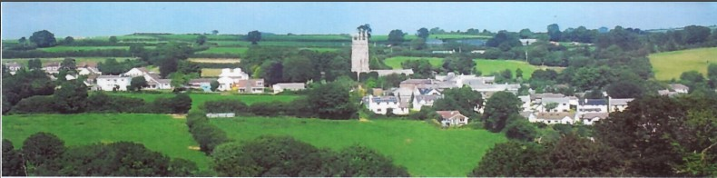

26th January 2025

Dear Councillor,

You are summoned to attend a meeting of North Hill Parish Council on Monday 3rd February 2025 at 7.30pm in the Village Hall.

Please find attached the agenda for our meeting. We ask that if any member of the public has issues, they would like to raise that they contact the clerk prior to the meeting so that we can best manage them.

Please remember that the time allotted for Matters of Community Concern is not a forum to discuss what has taken place during this meeting and that any matter raised here would likely be added to the NEXT meeting agenda for discussion.

Yours faithfully,

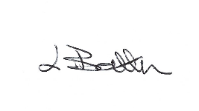

Lena Batten, Clerk to the Council

Members of the public are welcome to attend the meeting. However, we would like those attending to register prior to the meeting by emailing the Parish Clerk. Email: [northhillparishcouncil@btinternet.com](mailto:northhillparishcouncil@btinternet.com)

**AGENDA**

1. TO RECEIVE APOLOGIES:
2. CODE OF CONDUCT : a) TO RECEIVE DECLARATIONS b) TO GRANT DISPENSATIONS:

3. PUBLIC COMMENTS ON ITEMS ON THE AGENDA ONLY:

4. TO RECEIVE AND APPROVE THE MINUTES OF THE 6TH JANUARY 2025 FULL COUNCIL MEETING:

5. ANY MATTERS ARISING FROM PAST MINUTES NOT ON THE CURRENT AGENDA:

6. TO CONSIDER PLANNING APPLICATIONS RECEIVED FROM CORNWALL COUNCIL BY DATE OF THIS MEETING:

6.1 To note for information - PA24/08898 - Land South East Of Drogeada Close, Drogeada Close, Coads Green, Launceston, Cornwall, PL15 7LU - Proposal Prior notification of agricultural or forestry development for new fodder and machinery store - Prior approval not required.

6.2 To note for information – PA24/08792 - Potok House North Hill Launceston Cornwall PL15 7PQ -

Proposal Proposed roof alterations/extension, removal of existing chimney, replacement doors andwindows, Air Source Heat Pump, and PV solar panels - approved.

6.3 To note for information - PA24/08862 - Tregood Farm Bodmin Road Congdons Shop Launceston Cornwall PL15 7PN - Proposal Prior approval for change of use of two agricultural buildings to 2no. dwellinghouses – withdrawn.

6.4 PA25/00348 – Land South East of Moorfoot Mill, Mill Lane, Bathpool – application in principle for the construction of up to 1 dwelling. No site meeting has taken place due to new government rules on housing is the use of existing sheds/barns will automatically be granted permission.

6.5 To note for information - PA24/08417 – Trebartha, Barton, North Hill, Launceston, PL15 7PD - Proposal Listed Building Consent for construction of a new agricultural livestock building, creation of a new agricultural access and removal of an outdated livestock building – approved.

7. ANY APPLICATIONS RECEIVED BEFORE THE DATE OF THIS MEETING: None to date.

8. TO REVIEW CORRESPONDENCE AND TO AGREED RESPONSES REQUIRED:

8.1 To consider / resolve some form of memorial in memory of Cllr B. Ruby to be located in the Parish.

8.2 To accept the formal resignation of Cllr J. Harcourt as from the 1st January 2025.

8.3 To consider / receive the National Planning changes and Neighbourhood Plans briefing notes forwarded on the 11th January 2025 and consider any comments on the policy position statement.

8.4 To consider next steps in relation to potential changing of bank account.

8.5 To review / re adopt North Hill Parish Council Code of Conduct.

8.6 To consider any response from the email received regarding the Climate and Nature Bill.

8.7 To agree / accept the 2025-2026 quote for emptying of the dog poo bins at £604.92 plus VAT.

8.8 To confirm Bathpool public access defibrillator cabinet now has a bleed control kit installed, to resolve whether to subscribe to the annual payment of £40.00 per annum maintenance.

8.9 To consider / resolve any actions as a result of the latest Kompan inspection report.

9. TO REVIEW DETAILS FOR NORTH HILL PARISH COUNCIL CEMETERY:

Currently no details to review, Cemetery Committee will arrange a further meeting for early spring.

10. APPROVAL OF THE LIST OF PAYMENTS / RECEIPTS FOR 2024 & TO RECEIVE BANK STATEMENT:

10.1 AUTHORISATION OF EXPENSES INCLUDING SALARY:

i) £18.00 (PAYE G. Pollard payroll January, dd)

ii) £759.20 (Lena Batten, Salary / tax)

iii) £43.64 (room rent)

iv) £17.77 (emptying of additional dog poo bin)

v) £43.20 (renewal of email account for 2025-2026)

vi) £28.89 (Lena Batten, Ink)

vii) £45.00 (village hall room hire, Oct, Nov, Dec)

10.2 RECEIPTS: None.

10..3 To receive bank statement:

Bank Statement as of 28th January 2025 £15,681.23

11. TO REVIEW MONTHLY BUDGET RECONCILIATIONS:

11.1 Budget Sheet Attached.

12. TO REVIEW MONTHLY RAG: (Red, Amber, Green)

12.1 RAG Sheet attached.

13. REPORT FROM CORNWALL COUNCIL WARD MEMBER COUNCILLOR PARSONS:

14. ITEMS FOR INCLUSION AT THE NEXT MEETING:

15. DATE & TIME OF NEXT MEETING:

16. CLOSE OF BUSINESS: